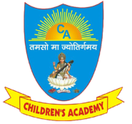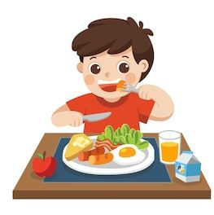

**MEAL CHART**

|  |  |
| --- | --- |
| **DAY** | **FOOD ITEMS** |
| **MONDAY** | PARANTHA WITH VEGETABLE/ GREEN VEGETABLE |
| **TUESDAY** | STUFFED PARANTHA WITH PICKLE OR JAM |
| **WEDNESDAY** | HOME MADE SNACKS |
| **THURSDAY** | PURI/PARANTHA VEGETABLE |
| **FRIDAY** | PUDDING (KHEER, DALIYA,HALWA) |
| **SATURDAY** | ANY TYPE OF FOOD (CHOLE PURI, BREAD PAKORA, DOSA, FRIED  RICE ETC.) |

***INSTRUCTION: -* • *No junk food allowed in Tiffin box and school bag.***

**• *Bring fruits daily (seasonal fruits).***

**• *Kindly don’t send processed items.***

**• *Kindly make sure that your ward carries /brings one spoon and one***

***hand towel/lunch towel (washed) daily to school.***

**• *No Maggi, Macroni and Omlet in Tiffin box.***